1. first talk
   1. no need config too much, unzip and run solution file RestfulSample.Web.sln
   2. rebuild all project
   3. this is very dumy code sample, base on this you can develop your own
   4. you can rewrite code to wrap httpwebrequest in app desk
2. requirement
   1. c#, .net framework 4.5
   2. config host file in folder window
   3. iis setup website in local
3. design
   1. restful api project (web services)  
      the servcies to manipulate data
      1. RequestObject
      2. ResponseObject
   2. desktop project (client request to restful)  
      the client request to restful to manipulate data
      1. RequestObject
      2. ResponseResult
4. code
   1. GlobalContext  
      Singleton instance SessionManger and Repository
   2. Repository (data manipulation)
      1. SampleRepository (Insert, Update, Delete, Select, SelectAll)
   3. SessionManager
      1. AppSessionManager ( init apikey and create token for session connect)
   4. simple resful api (SampleController)  
      get all data  
      <http://sample.api/api/sample/>   
      get data by id  
      [http://sample.api/api/sample/{id}](http://sample.api/api/sample/%7bid%7d)   
      post to insert  
      <http://sample.api/api/sample/>   
      put to update  
      [http://sample.api/api/sample/{id}](http://sample.api/api/sample/%7bid%7d)
   5. simple custom response (SampleResponseController)  
      <http://sample.api/api/SampleResponse/>
   6. application authenticate (AppController)  
      get token by apikey  
      [http://sample.api/api/app/GetToken/{apikey}](http://sample.api/api/app/GetToken/%7bapikey%7d)
   7. simpe window form to work with restful
5. setup
   1. iis  
      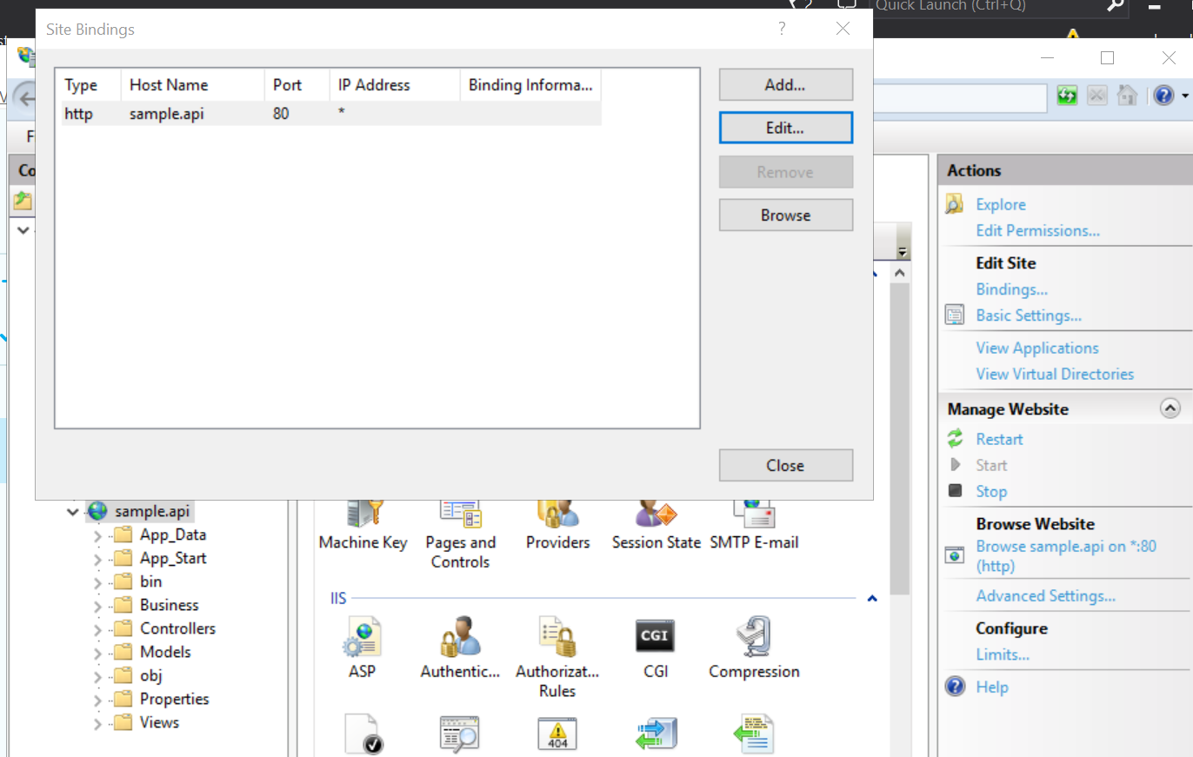  
        
      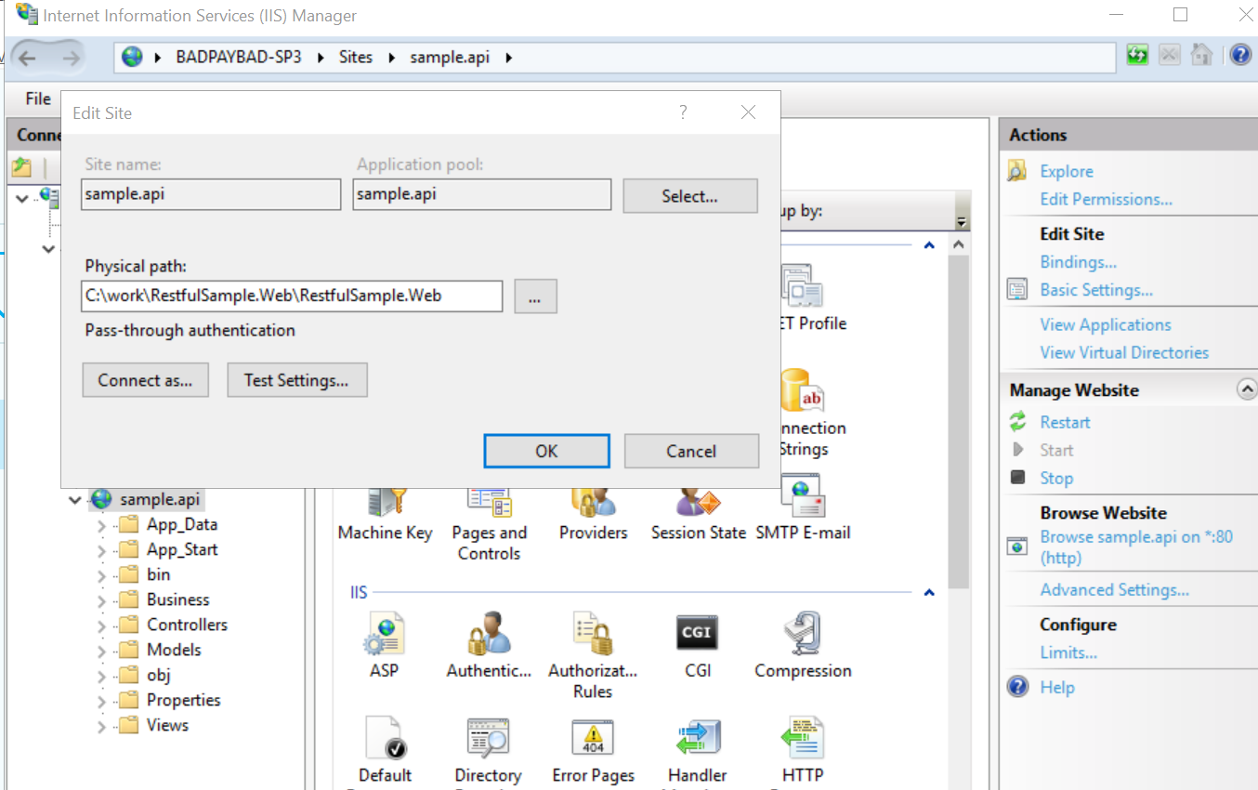
   2. web project  
      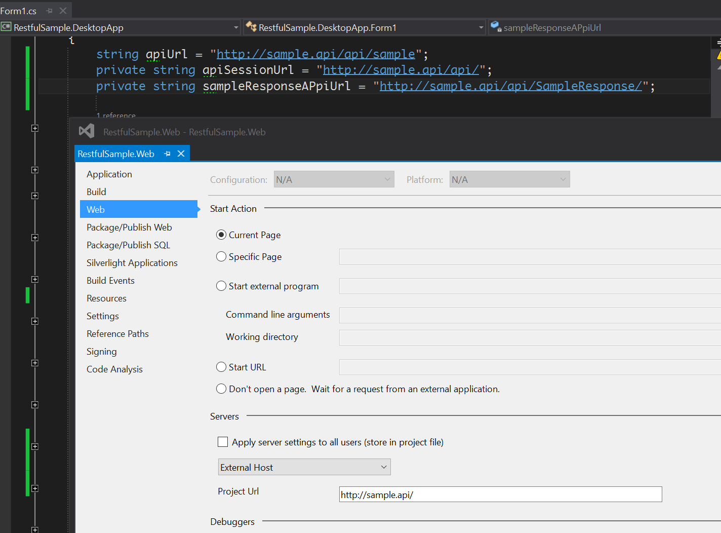
   3. host file  
      